**SQL - Join Exercise**

For the following questions, go to :

**https://www.w3schools.com/sql/trysql.asp?filename=trysql_op_in** 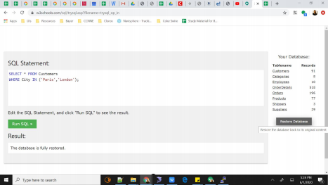

You will see the above page, click on restore database.

The tables and the data can be referred to from the ‘Your Database’ on the right side by clicking on the table names. Solve the following questions using SQL Command:

|  |
| --- |
| 1. Display the Employee details corresponding to OrderID=10261. |
| 2. Display the ShipperName for OrderID=10318. |
| 3. Display the OrderIDs who ordered for an item which has 1 kg pkg. Unit. |
| 4. Display the Order date when the Customers from the city, ‘Buenos Aires’ placed an order. |
| 5. Display the Customer names who ordered the costliest product. |
| 6. Display the Category name of the product which was ordered in quantity=33. |
| 7. Display the Product name which has the highest quantity of order. |

|  |
| --- |
| 8. Display the Customer names who placed an order after ‘1997-02-07’. |
| 9. Display the Customer names who ordered less than quantity=2 in their orders. |
| 10. Display the sum of the price of products that was ordered in the OrderID=10263. |

**Submission Format:**

Write your queries in a word document and upload the same.